EDUCACIÓ FÍSICA

Name: Queralt Ribé & Leila Medina Course: 3 ESO C

Sport:
Basketball
Activity 1
Name: the game of 21
Explanation: It’s a game where you need to score 21 points in the less time possible. You cannot pass number 21. If you score one basket it’s two points, then you have a free shot and it’s one point.
Material: 3 Basket balls
Time: 15 minutes
Groups: 3 groups
Image:
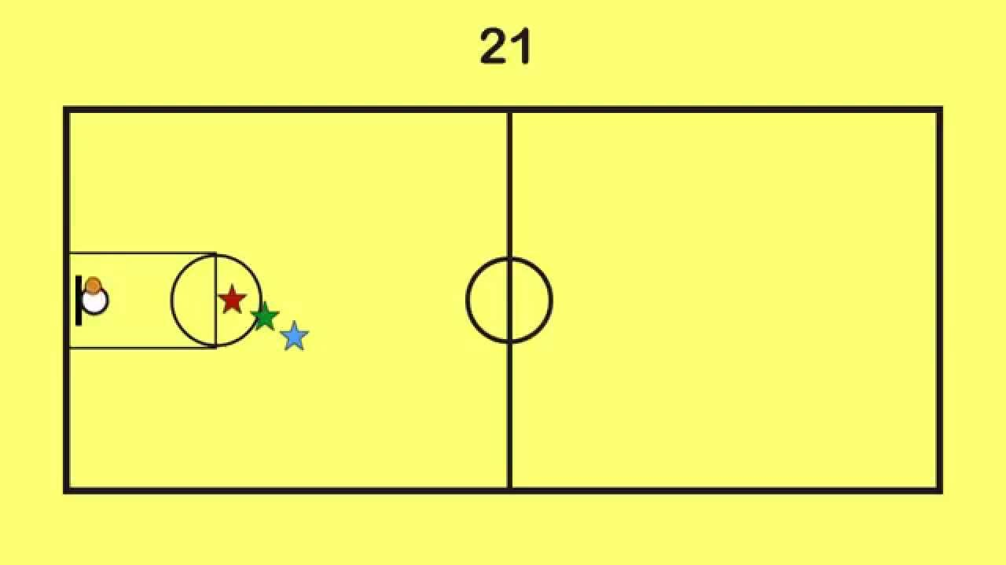

Activity 2
Name: 10 pass
Explanation: You need to make 10 pass and then try to score and it can’t touch the floor. If it touch the ball is for the other team.
Material: petos and basket balls
Time: 15 minutes
Groups: 4 groups. 3 groups of seven and 1 of six
Image:
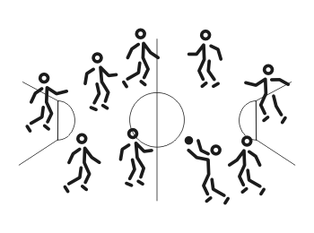
Activity 3:
Name: The game of the handkerchief with a ball
Explanation: It’s like the game of the handkerchief but with a basket ball. A person is going to say a number and the persons of the teams who have the number need to run to the person who have the ball and try to score in the basket. If you can’t the point is going for the other team.
Material: Basket ball
Time: 15 minutes
Groups: 2
Image:
